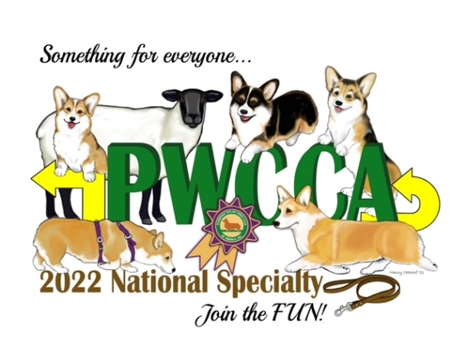
2022 PWCCA HERDING TRIALS
LUNCH RESERVATIONS
ORDER FORM

MEAT OPTIONS BREAD OPTIONS
Sat Sun Sat Sun
Turkey/Cheese Wrap
Ham/Cheese Croissant
Chicken Salad Hoagie
Vegetarian
Each Lunch is $18 and includes: Sandwich, salad, chips, cookie and bottled water
*NOTE-The herding trial site is approximately 6 miles from Bowling Green KY
Total Included ___________________________
Name: ____________________________________________________
Address: ___________________________________________________
Phone #: ___________________________________________________
E-mail: _____________________________________________________
All order must be received or post-marked no later than Friday Sept 16th. If you have any questions or mail your order close to the dead-line please contact Millie at Kallista@scrtc.com
Make Checks payable to PWCCA
Mails check and forms to: Millie Williams
5100 Tompkinsville Road,
Summer Shade KY 42166

